Easy VBA Homework solution images

1. Sheet 1: Year 2016

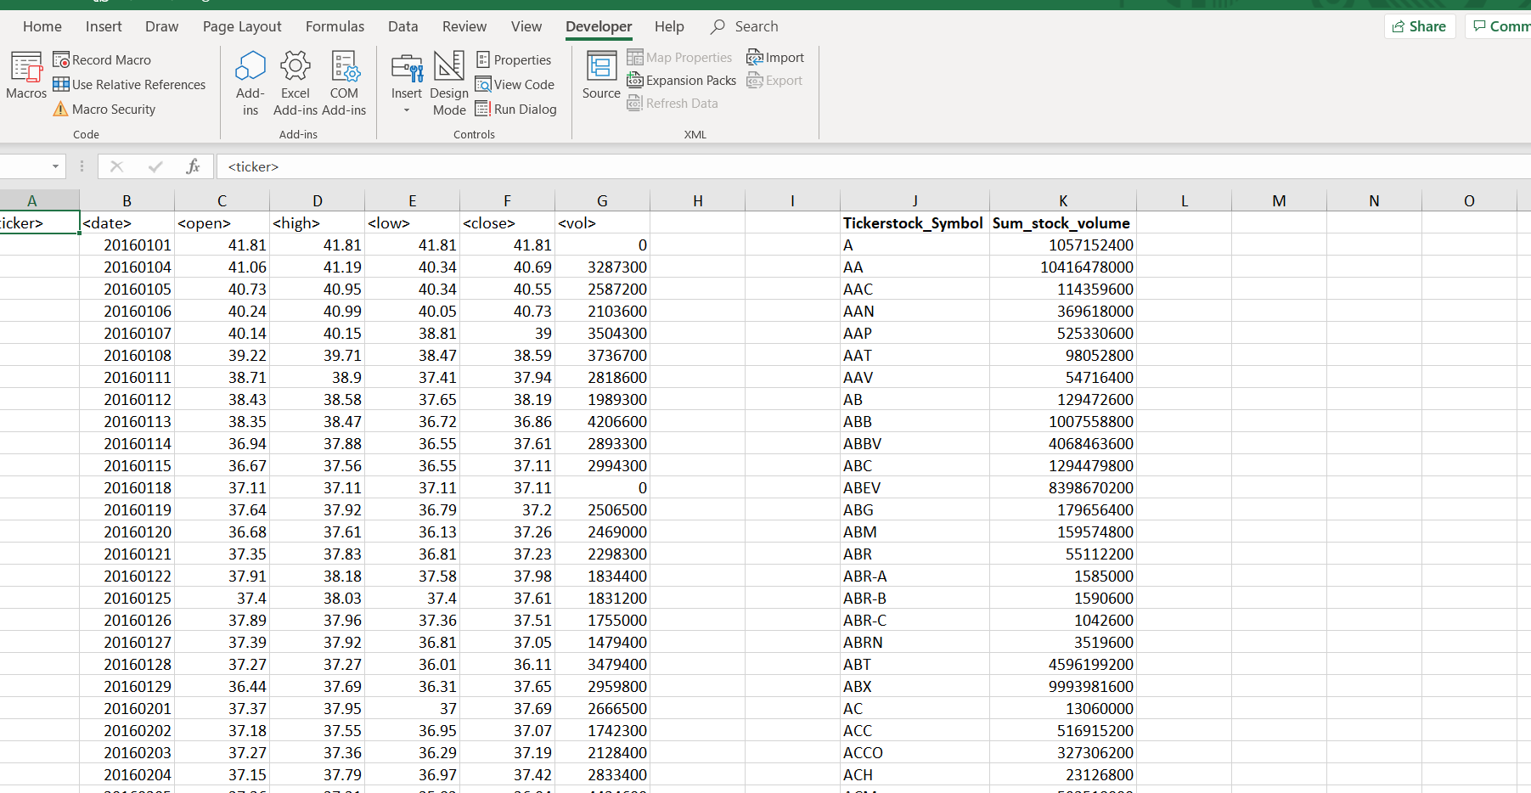

Sheet 2, Year 2015

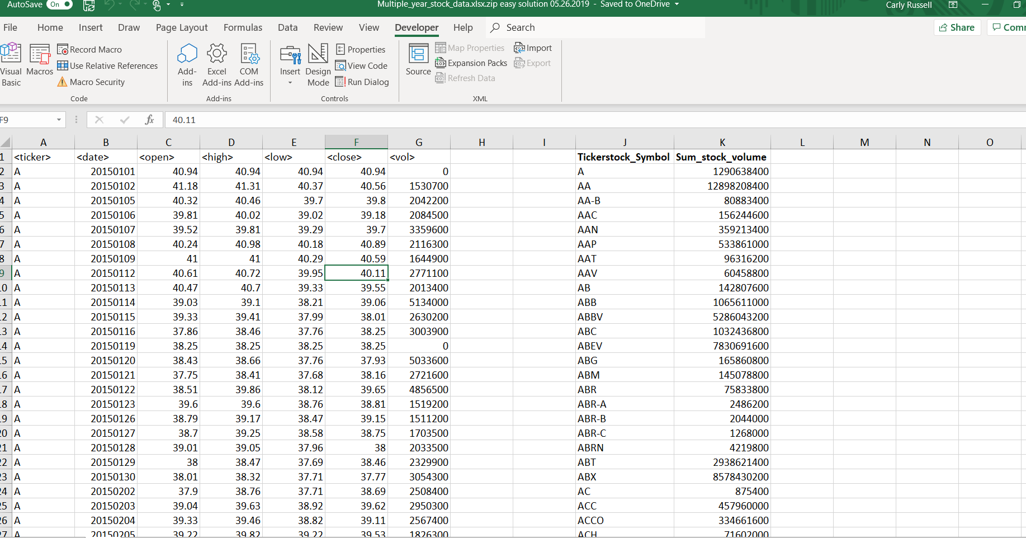

Sheet 3, Year 2014

